New and Notable Juvenile Non-fiction 2019

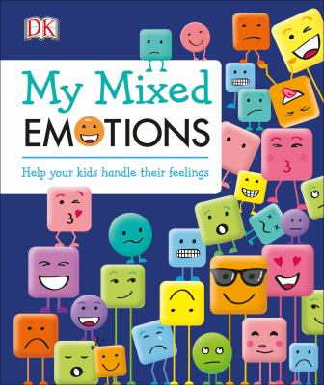
My mixed Emotions: Help your kids handle their feelings
Elinor Greenwood, author.
9781465473325
Feelings can be complicated, and learning to express them is a skill that must be developed. My Mixed Emotions is here to coach children through a variety of emotions and situations.
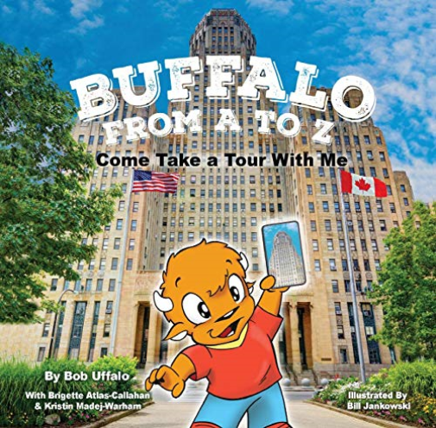
Bufalo from A to Z
Brigette Atlas-Callahan, author.
9781942483618
Accompany Bob Uffalo as he takes children to dozens of destinations around Buffalo and Western New York in Buffalo from A to Z.
Fakers: An Insider’s Guide to Cons, Hoazes, and Scams
H.P. Wood, author.
9781580897433
Offers an overview of some of the funniest, weirdest, and most influential cons, scams, and deceptions in history, looking at how the fakers do it, why people can be so easy to fool, and how readers can avoid becoming a sucker.
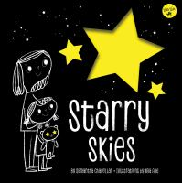
Starry skies
Samantha Chagollan, author.
9781633225091
Learn about the constellations above us. Every night, the sky is filled with stars that tell a thousand stories. From brave warriors to ferocious beasts and magical friends, each star shines brightly.
Around the World in 80: the fabulous ways to get from here to there
Henrietta Drane, author.
9781465475725
Describes eighty different modes of transportation, from horse-drawn chariots and steam locomotives to tandem bicycles, double-decker buses, snowmobiles, and space shuttles.
Buried lives: the enslaved people of George Washington's Mount Vernon
Carla Killough McClafferty, author.
9780823436972
When he was eleven years old, George Washington inherited ten human beings. Using fascinating primary source material and photographs of historical artifacts, the author sheds light on the lives of several of the men and women enslaved by the Washington family.
The roots of rap: 16 bars on the 4 pillars of hip-hop
Carole Boston Weatherford, author.
9781499804119
Presents the history of hip-hop including, how it evolved from folktales, spirituals, and poetry, to the showmanship of James Brown, to the culture of graffiti art and breakdancing that formed around the art form.
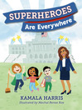
Superheroes are everywhere
Kamala D. Harris, author.
9781984837493
The United States senator recounts how she looked for superheroes in her everyday life as a child, finding them in her parents, her teachers, and her friends.
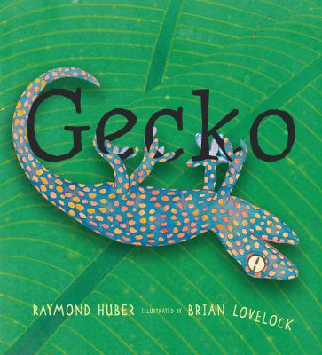
Gecko
Raymond Huber, author.
9780763698850
Meet the gecko--the escape artist of the lizard world! Hawks and rats would love to catch one for their dinner, but the gecko's amazing ability to protect itself keeps it safe for another day. With cunning camouflage, feet covered with tiny hairs for gripping (even upside down!), and the ability to drop its tail as a decoy, the gecko is more than a match for its pursuers.
The sea mammal alphabet book
Jerry Pallotta, author.
9781570911460
Alphabet counting book featuring a variety of seas mammals.
Rotten! : vultures, beetles, slime, and nature's other decomposers Anita Sanchez, Anita, author.
9781328841650
Describes the process of decomposition, discussing the role of decomposers such as sharks, vultures, and earthworms, and includes experiments demonstrating how decomposition supports new life.
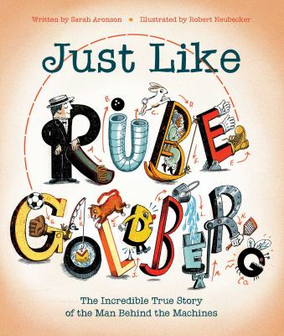Just like Rube Goldberg : the incredible true story of the man behind the machines
Sarah Aronson, author
9781481476683
Brilliant ideas from wonderful women Aitziber Lopez, author.
9781786037053
Introduces the women who invented automobile heating, Monopoly, dishwashers, syringes, and more.
Instagraphics: a visual guide to your universe
Dan Green, author.
9781338215571
Provides an illustrated look at hundreds of facts and figures about the world, from the farthest animal migrations and the fastest vehicles to the power of the human brain and the world's most deadly creatures.

A beautiful day in the neighborhood : the poetry of Mister Rogers
Fred Rogers, author.
9781683691136
Lyrics to seventy-five songs from the children's television programs Mister Rogers' Neighborhood and The Children's Corner, collected and presented as an illustrated treasury of poems. Lyrics explore topics such as feelings, new siblings, everyday life, and imagination
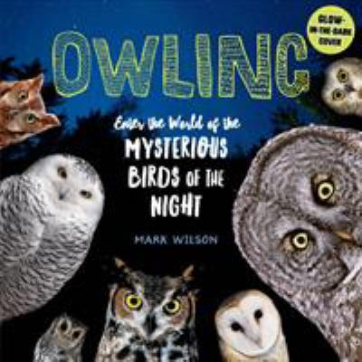
Owling : enter the world of the mysterious birds of the night
Mark Chester Wilson, author.
9781612129624
The zoom, fly, bolt, blast steam handbook : build 18 innovative projects with brain power
Lance Akiyama, author.
9781631596100
Rockport's creative engineering extraordinaire, Lance Akiyama, returns again with Zoom, Fly Bolt, Blast STEAM Engineer and 18 STEAM approved projects to get kids doing, thinking, and building
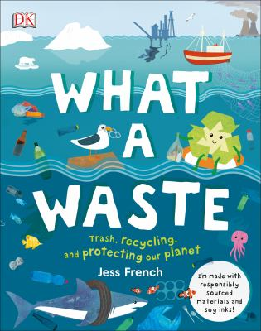
What a waste
Jess French, author.
9781465481412
Everything you need to know about what we're doing to our environment, good and bad, from pollution and litter to renewable energy and plastic recycling. This environmental book will teach keen young ecologists about our actions affect planet Earth.
When Sue found Sue: Sue Hendrickson Discovers her T. Rex
Toni Buzzeo, author.
9781419731631
From a very young age, Sue Hendrickson was meant to find things: lost coins, perfume bottles, even hidden treasure. Her endless curiosity eventually led to her career in diving and paleontology, where she would continue to find things big and small. Named in Sue's honor, Sue the T. rex would be placed on permanent exhibition at the Field Museum of Natural History in Chicago.
Beyoncé : shine your light
Sarah E. Warren, author
9781328585165
Follow the story of Beyoncé as she finds her voice through trials and triumphs, and understand that you too can shine your light like Beyoncé.
Groundbreaking guys : 40 men who became great by doing good Stephanie True Peters, author.
9780316529419
These great men were not always good men. It's time for our role models to change. This book pays tribute to Mr. Rogers, Barack Obama, Hayao Miyazaki, and more: men whose masculinity is grounded in compassion and care.
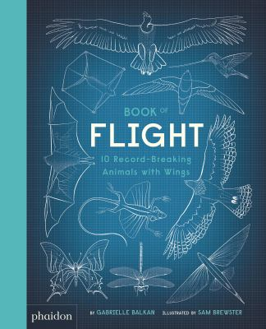
Book of flight : 10 record-breaking animals with wings
Gabrielle Balkan, author.
9780714878683
A stunning world-records book of animal flight, by the author-and-illustrator team behind the bestselling Book of Bones! Meet ten fascinating flyers through a series of superlatives - and guess who's who while learning about airborne animals.
Like a lizard
April Pulley Sayre, author.
9781629792118
Live the lizard life by exploring the behaviors of 28 different types of lizards. Imagine swooping through the air, curling into a circle, and even running across water!
We are the gardeners
Joanna Gaines, author
9781400314225
Joanna and the kids chronicle the adventures of starting their own family garden. From failed endeavors, obstacles (bunnies that eat everything!), and lessons learned, the Gaines family shares how they grew a happy, successful garden. As it turns out, trying something new isn't always easy, but the hardest work often yields the greatest reward.

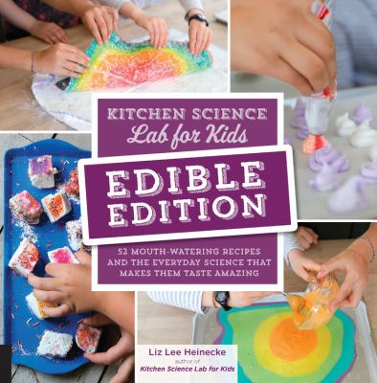
Kitchen science lab for kids : 52 mouth-watering recipes and the everyday science that makes them taste amazing
Liz Lee Heinecke, author.
9781631597411
When you step into your kitchen to cook or bake, you put science to work. Physics and chemistry come into play each time you simmer, steam, bake, freeze, boil, puree, saute, or ferment food. Knowing something about the physics, biology, and chemistry of food will give you the basic tools to be the best chef you can be.
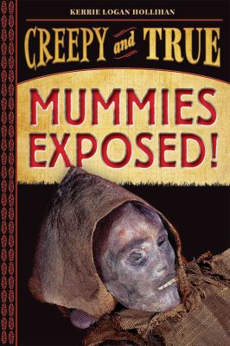
Mummies exposed!
Karrie Logan Hollihan, author.
9781419731679
Just when you think that you know everything there is to know about mummies, new ones are discovered! Packed with facts but light in tone, this book introduces young readers to the most compelling examples of mummies from all over the world. There are many books about Egyptian mummies, but Mummies Exposed! goes beyond what you expect and uncovers both old favorites and recent discoveries; among them a Moche princess in Peru, the bog people of England and Ireland, and a Buddhist monk discovered within a sculpture!
Fanatical about frogs
Owen Davey, author.
9781912497980
Did you know...that some frogs can grow as big as a newborn baby, while others are smaller than your fingernail? Or that frogs eat their prey whole, using their eyes to swallow their food? With over 7,000 species of frog, there's plenty to discover about these watery wonders!
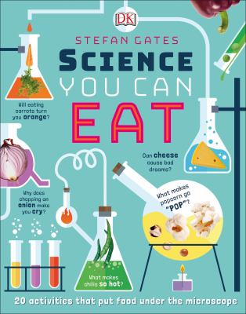
Science you can eat
Stafan Gates, author.
9781465468437
Explores the science behind food, nutrition, and cooking. Includes twenty experiments for young readers to further understand the science at home.
The girl who named Pluto : the story of Venetia Burney
Alice B. McGinty, author.
9781524768317
When Venetia Burney's grandfather reads aloud from the newspaper about a new discovery--a "ninth major planet" that has yet to be named--her eleven-year-old mind starts whirring. She is studying the planets in school and loves Roman mythology. "It might be called Pluto," she says, thinking of the dark underworld. Here is a picture book perfect for STEM units and for all children--particularly girls--who have ever dreamed of becoming a scientist.
Titanosaur : discovering the world's largest dinosaur
José Luis Carballido, author.
9781338207392
Through a combination of photographs and illustrations, this picture book will tell the story of the discovery of this new dinosaur, while weaving in exciting facts about what life was like for this brand new species that doesn't even have an official name yet!
You are my friend : the story of Mister Rogers and his neighborhood Aimee Reid, author.
9781419736179
Mister Rogers is one of the most beloved television personalities ever, but before he was the man who brought us "Mister Rogers' Neighborhood", he was just little Freddie Rogers. You Are My Friend tells how Fred was a sickly and lonely child. At school, he was bullied and had trouble making friends and expressing his feelings. His parents and grandparents encouraged Fred to ask for help and explore his world. When Fred grew up he became a champion of compassion, equality, and kindness, and he realized that he could spread his message through television. His simple message still resonates with us today: 'There's no person in the world like you and I like you just the way you are.' Outside of recent news, You Are My Friend will endure because of its smart writing, focus, and gentle homage to a very popular, kind, understated, good soul and role model
